Process Definition Document (PDD)

*Process Name: Top Box Office Movies (US)*

Table of Contents

**Introduction** **1**

Purpose of the Document 1

Objectives 1

Process Key Contact 1

Minimum Prerequisites for Automation 1

**As-Is Process Description** **2**

Process Overview 2

Applications used in the Process 3

As-Is Process Map 3

**To-Be Process Description** **3**

Detailed Process Map 3

Robot Type 4

Business Exceptions Handling 4

Known Exceptions 4

Unknown Exceptions 4

System Exceptions Handling 4

**Other Observations** **5**

**Additional sources of process documentation** **5**



# Introduction

## Purpose of the Document

The Process Definition Document outlines the business process chosen for automation using UiPath Robotic Process Automation (RPA) technology.

The document describes the sequence of steps performed as part of the business process, the conditions and rules of the process prior to automation and how they are envisioned to work after automating it, partly or entirely. This specifications document serves as a base for developers, providing them with the details required for applying robotic process automation to the selected business process.

## Objectives

The business objectives and benefits expected by the Business Process Owner after automation of the selected business process are:

* Getting all the top box office movies from IMDb Website.
* Sending all the top box office movies’ data to the user mail.
* The process should run once a week (Every Tuesday at 12 AM)

## Process Key Contact

The specifications document includes concise and complete requirements of the business process and it is built based on the inputs provided by the process Subject Matter Expert (SME)/ Process Owner.

The Process Owner is expected to review it and provide signoff for accuracy and completion of the steps, context, impact and a set of process exceptions. The details are to be included in the table below.

|  |  |  |  |
| --- | --- | --- | --- |
| Role | Name | Contact Details  (email & phone number) | Notes |
| Process Owner | Ahmed Abd Elfatah Mohamed | abdelfattah.demerdash@gmail.com |  |
| Business Analyst | Ahmed Abd Elfatah Mohamed | abdelfattah.demerdash@gmail.com |  |

## Minimum Prerequisites for Automation

|  |  |
| --- | --- |
| Met (Y/N) | Prerequisites |
| Y | A filled in and completed Process Definition Document |
| Y | Closure of any open process questions |
| Y | Environment set up |
| Y | Test Data to support development and testing |
| N | User access and creation of user accounts (licences, permissions, restriction to create accounts for robots) |

# As-Is Process Description

## Process Overview

General information about the process selected for RPA prior to automation.

|  |  |  |
| --- | --- | --- |
| # | Item | Description |
| 1 | Process Full Name | Movie Review |
| 2 | Process Area | Personal |
| 3 | Department | Fun |
| 4 | Process Short Description  (operation, activity, outcome) | Gets top box office movies' ratings in US and mails it to the user account. |
| 5 | Role(s) required for performing the process | Any |
| 6 | Process schedule and frequency | Every Week (Every Tuesday at 12 AM) |
| 7 | # of items processed /reference period | 10 |
| 8 | Process execution time | 4 – 5 seconds/movie |
| 9 | Peak period(s) | N/A |
| 10 | Transaction Volume During Peak period | N/A |
| 11 | Total # of FTEs supporting this activity | N/A |
| 12 | Expected increase of volume in the next reference period | N/A |
| 13 | Level of exception rate | N/A |
| 14 | Input data | User mail, IMDb link and rotten tomatoes link as assets on the orchestrator. |
| 15 | Output data | All top box office movies’ ratings sent to the user mail as excel file. |

*Add more rows to the table to include relevant data for the automation process. No fields should be left empty. Use “n/a” for the items that don't apply to the selected business process.

## Applications used in the Process

The table includes a comprehensive list of all the applications that are used as part of the process to be automated to perform the given steps in the flow.

|  |  |  |  |  |  |
| --- | --- | --- | --- | --- | --- |
| # | Application Name & Version | System Language | Thin/Thick Client | Environment/ Access Method | Comments |
| 1 | Microsoft Edge  109.0.1518.78 | English | Thin | PC |  |
| 2 | Microsoft Excel  2013 | English | Thin | PC |  |
| 3 | Microsoft Outlook  2013 | English | Thin | PC | The Email should be signed in. |

*Add more rows to the table to include the complete list of applications.

## As-Is Process Map

**High Level As-Is Process Map:** This chapter depicts the As-Is business process at a High Level to enable developers to have a high-level understanding of the current process.

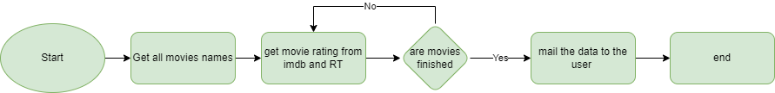

|  |  |  |  |
| --- | --- | --- | --- |
| # | Step Action/Description | Screenshot | Remarks |
| 1 | Open Microsoft Edge browser with the provided IMDb link. |  |  |
| 2 | Open Rotten tomatoes with the provided link. |  |  |
| 3 | Read all Top Box Office movies’ names. |  | Data Scrapping |
| 4 | For each movie perform the following | N/A |  |
| 4.1 | Open the movie’s page on imdb |  |  |
| 4.2 | Save movie’s IMDB rate and IMDB link. | N/A |  |
| 4.3 | Open the movie’s page on Rotten tomatoes. |  |  |
| 4.4 | Save the movie’s tomato and audience score. |  |  |
| 5 | Write all the movies’ data to an excel file. |  |  |
| 6 | Send the excel file to the provided user mail through Outlook. | N/A | Outlook mail should be signed in. |

# To-Be Process Description

## Detailed Process Map

**Detailed Process Map:** This chapter depicts the To-Be automation process at a detailed view to enable developers/COE to see the workflows involved in the RPA solution

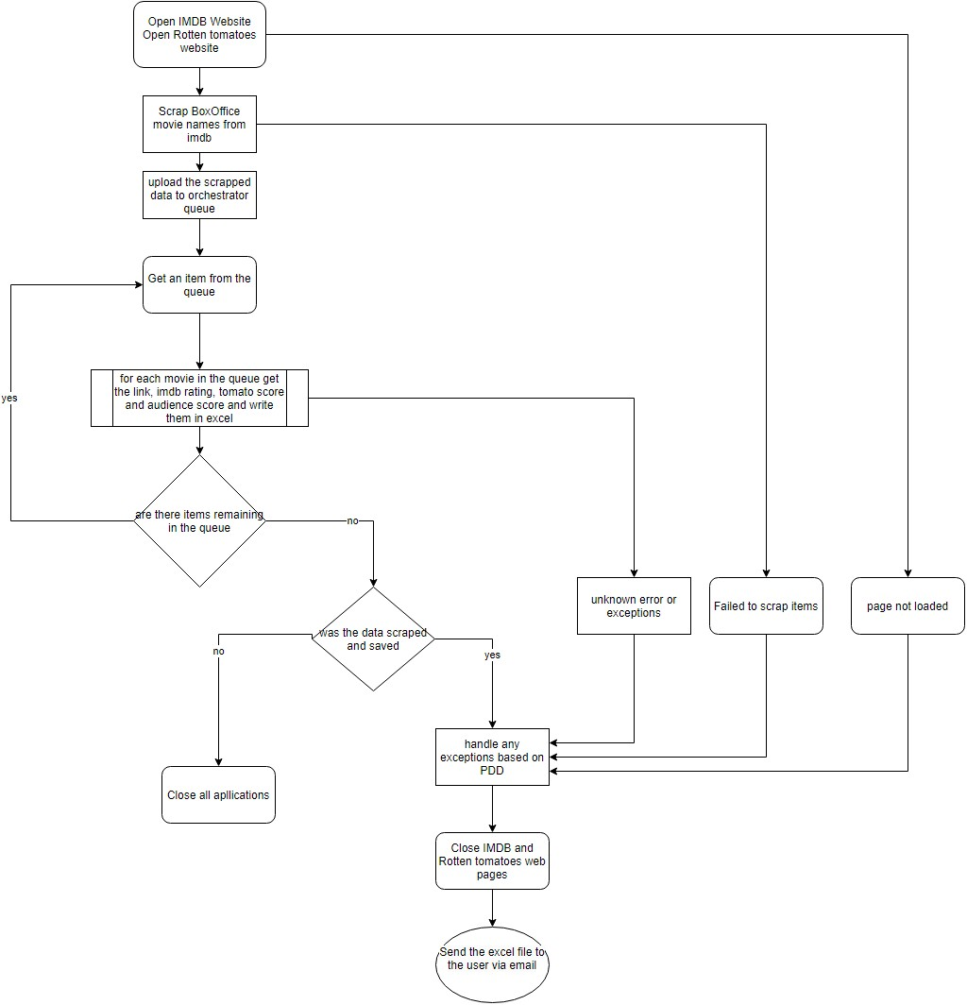

|  |  |  |  |  |  |
| --- | --- | --- | --- | --- | --- |
| **Workflow Name** | **Description** | **Pre-conditions** | **Post-actions** | **Arguments** | **Notes** |
| IMDb_Open  (intilization) | Opens the IMDb web site in a new session of edge browser. | Internet Connection. | IMDb box office page opened successfully. | N/A. |  |
| RT_Open  (intilization) | Opens the rotten tomatoes web page. | N/A. | Rotten Tomatoes home page opened successfully. | N/A. |  |
| IMDb_Scrap  (AddTransactionData) | Gets the top box office movies'. | IMDb box office page opened successfully. | Scraped box office movies’ names successfully. | Out_DT_Movies |  |
| UploadQueueItems  (AddTransactionData) | Populates the queue with the provided work items. | Scraped box office movies’ names successfully. | N/A. | in_DT_Movies | Queue Name: Movies |
| GetTransactionItem  (GetTransactionData) | Gets the queue item from the Queue | N/A. | N/A. | Out_Transactionitem |  |
| IMDB_Searchformovies  (ProcessTransaction) | Search the IMDB web site for the movie. | Imdb page was open | Navigated successfully to the movie’s page. | In_transactionitem  Out_str_link |  |
| IMDB_GetRating  (ProcessTransaction) | Get the rating of the movie | Navigated successfully to the movie’s page. | Obtained the imdb rate. | Out_Str_Rate |  |
| RT_SearchForMovie  (ProcessTransaction) | Search the Rotten Tomatoes web site for the movie. | Rotten tomatoes page was open. | Reached the movie’s page. | In_transactionitem |  |
| RT_GetData  (ProcessTransaction) | Get the tomato meter and audience score of the movie | Reached the movie’s page. | Obtained the tomato score and audience score for the movie | Out_Tomatoscore  Out_Audiencemeter |  |
| Excel_write  (ProcessTransaction) | Write the data to an excel file. | Obtained all the needed data successfully. | Excel file created and filled was data. | In_transactionitem  In_str_link  In_Tomatoscore  In_Audiencemeter  In_str_rate  In_DT_Results |  |
| IMDB_Close  (CloseApplications) | Close the IMDB web site | Imdb page was open | N/A. |  |  |
| RT_Close  (CloseApplications) | Close Rotten tomatoes web site | Rotten tomatoes page was open | N/A. |  |  |
| Outlook_SendEmail | Send an outlook mail with the results. | 1 - The provided data table is not empty.  2 - All scraped movies are processed successfully with no errors. | N/A. | In_DT_Results | Outlook installed and signed in. |

## Robot Type

|  |  |  |  |  |
| --- | --- | --- | --- | --- |
| # | Attended | Unattended | Trigger | Comments |
| 1 |  | ✓ |  |  |

## Business Exceptions Handling

The Business Process Owner and Business Analysts are expected to document below all the business exceptions identified in the automation process. These can be classified as:

### Known Exceptions

The table below reflects all the business process exceptions encountered during the process evaluation and documentation. These are known exceptions that occurred before. For each of these exceptions, define a corresponding expected action that the robot should complete if it encounters the exception.

|  |  |  |  |  |
| --- | --- | --- | --- | --- |
| BE # | Exception Name | Step | Parameters | Action to be Taken |
| 1 | N/A. | N/A. | N/A. | N/A. |

### Unknown Exceptions

For all other unanticipated or unknown business (process) exceptions, the robot should:

* Log the error and then end the Process.

## System Exceptions Handling

A comprehensive list of all errors, warnings or notifications should be consolidated here with the description and action to be taken, for each, by the robot.

Errors identified in the automation process can be classified as:

|  |  |  |  |  |
| --- | --- | --- | --- | --- |
| SE # | Exception Name | Step | Parameters | Action to be Taken |
| 1 | Application unresponsive / page not loading | Any step | Blanck Page / Couldn’t check the pre or post conditions of any workflow. | Close the application and retry for 2 times and then if the exception stays, end the process. |

### Unknown Exceptions

For all other unanticipated or unknown business (process) exceptions, the robot should:

* Retry 2 times and if the exception stays, take a screenshot to the whole screen and then end the Process.

Other Observations

Include below any other relevant observations you consider needed to be documented here.

* Future additions to input the country of the user as an asset.
* To send the top movies’ data for list of users’ mails.

Additional sources of process documentation

* A recorded video for the process running end to end – in the current directory as the PDD.
* A whiteboard, which is an excel file that contains all the workflows names and information.
* A document that contains the main aspects of the project - in the current directory as the PDD.
* A development specifications document - in the current directory as the PDD.